Time0intro for wrong and right card

- Moving on to remove the outliers assuming all the people with 0 secs are not into credit cards

Time intro for females (1 and 0)

Females trying to understand more about the card regardless of if they are buying or not

Time intro for males (1 and 0)

Report: Two peaks around (9 to 10 secs)which determine an important point that either they will continue after that time, or they will leave.

Time in pay for females (0 and 1)

Females again showing a pattern near to 9 and 10 secs which propose videos does catch the interest from first few seconds

Time in pay for males (0 and 1)

Males not buying the card shows a contradictory behaviour than female while as the they are losing interest by the video in first few seconds

Time no mem for females (1 and 0)

Similar pattern as they are not losing the interest, and they do try to get more information as the video progress

Time no mem for males (0 and 1)

Similar pattern to females which shows a different behaviour than other 2 schemes

Time foreign for females (0 and 1)

They try to see the videos, but they are losing interest in general

Times Foreign for Males (0 and 1)

The more the people get into video, the more chances of them buying

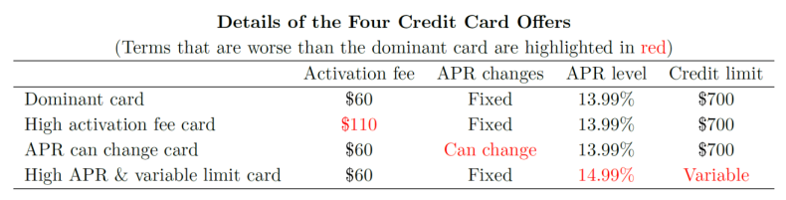

Assumptions:

1. Females are trying to understand more of the card than males regardless of buying the perfect card or not
2. If people are watching the video more than 9-10 secs there are more chances, they will buy it
3. Third National Bank with a tagline of **Minimum Payment Only $10/month** are having excellent but impact even before 9 secs which showcase two things
   1. Either the tagline is making sense, and it forces them to get the correct card
   2. Or the video itself is very Self-Introductory that people get the idea that it will be beneficial for them
4. No Foreign Transaction Fee is a standout and can be concluded people in general don’t transfer the money so you can see a negative ratio

Conclusion:

1. Each card is reacted differently with the video which gives evidence that video itself has an impact, but it can be stated that it is not significant.
2. Females are more decisive with video, but males lose interest quite at the start of video.

Future-Decisions:

1. Analyzing the videos as such if they introduce their main point in first few seconds or not?
2. Getting the algorithm for future marketing based upon the gender.